University of Asia Pacific
Department of Computer Science & Engineering
Mid-Semester Examination Spring -2020
Program: B. Sc. Engineering (3rd Year/1st Semester)
Course Title: Theory of Computation Course No. CSE 307 Credit: 3.00
Time: 1.00 Hour. Full Mark: 60

There are Four Questions. Answer questions 1, 4 and (2 or 3). All questions are of equal value/Figures in the right margin indicate marks.

1.a)  1.  b) | Describe formal definition of Nondeterministic Finite Automata using your own words.  Suppose, my name is ‘nadeem ahmed’. I use first name (first 3 letters) and last name (first 2 letters) in the below automata.  The alphabet only consists of used input symbols.  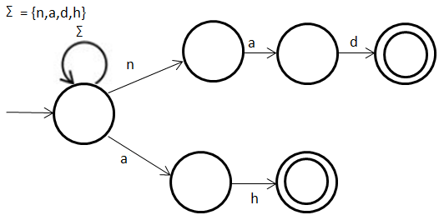  Use your own name in the figure (states are fixed), draw it in your script and then convert it into DFA. | 8  12
2.  3. | Suppose, my name is ‘abdul baten’. I use the first letter of my first and last name in the below Є-NFA. Use first letters of your own name (first name and last name) in the figure, draw it in your script and then:  - Find out the Є-closure for each state.  - Convert it into DFA. Show both transition table and diagram.  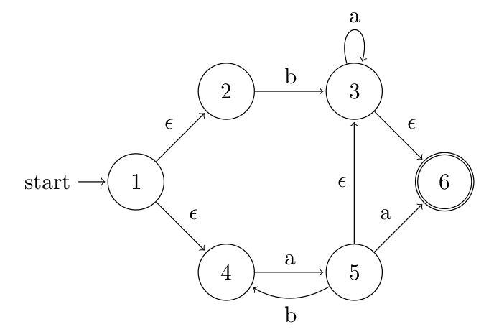 | 10+  10
3.a)  2  .b) | Let ∑ = {the letters/symbols of your own name}  Suppose you are wanting to construct the following language:  “The set of all strings that either start with your first name or last name.”  i) Write the regular expression for this language.  ii) Draw the corresponding NFA.  Suppose, my name is ‘anisuzzaman’. I take only first four letters for the state name. Use first four letters of your own name and then convert the following NFA into DFA. Show both transition table and diagram of the DFA.  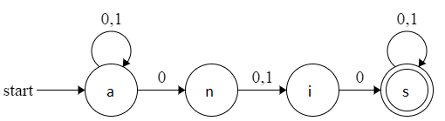 | 4+4  12
4.a)  4.  b) | Suppose, my id is 17101021. First two digits (17) stand for admission year 2017, then next digit (1) stand for Spring semester (i.e. 2 stands for Fall semester), then 01 which stands CSE department (0x indicates another department), and last three digits (021) stands for my class roll.  Now, write your own id and then write a regular expression for all the id’s of your class. Please note:  - Year is same as your admission year.  - It includes both Fall and Spring semester.  - The range of class roll is 001 to 999.  Write a regular expression for a website. Rules are given below:  - May start with:(https://www, https://, www) or may not present  - If prefix is www then there will be dot (.) otherwise not.  - Followed by website name at least (length of your first name) alphanumeric characters and at most (length of your full name) alphanumeric characters.  - Then there will be dot (.)  - Ending domain names are:(com, org, net, int, edu, gov, mil) | 12  8

For each question, single space between lines.
1½ Space between consecutive questions.

